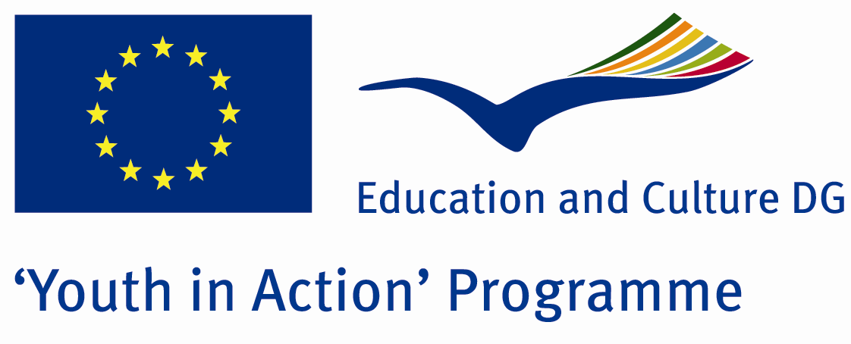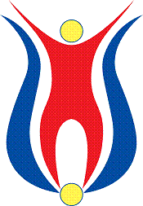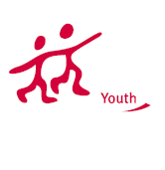

Women Are Like Flowers

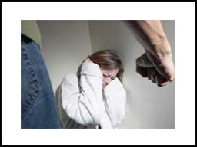

ACTION 4.3 – Training And Networking

01-07th July 2011

Amasya/TURKEY

Please contact directly to;

adventurerpeacepigeons@gmail.com

Project Summary;
This project will be realized by young leaders and youngsters who come from different countries. We aim that we provide our guests to learn more information about human rights. And to point violence against women and to get everybody to comprehendwomen’s importance in ourlife. Women is take up in our life. They are our mothers who born and grow us, they are sisters and friends who is always with us, they are wife who share her life. But in the earth men is powerful and they violence against women. This violence is all over the world not only poor country or unschooled country. According to the UN, violence against women is "Violence that is directed at a woman because she is a woman or that affects women disproportionately". Each year across the UK 3 million women experience violence, and there are many more living with the legacies of abuse experienced in the past. In the UK it includes: domestic violence, rape and sexual violence, sexual harassment, female genital mutilation, forced marriage, crimes in the name of honour, trafficking and sexual exploitation. It is mostly committed by men that women know or are in a close relationship with. We will make Poster competition about the violence against women. Our guests will give information about their country and we will make brainstorming. To sum up, our aim is to give some information about violence against women and learn women's rights.

Project Title; Women Are Like Flowers

Date and Venue; 01-07th July 2011 Amasya/TURKEY

Target Group; Non profit/non governmental organization, Public body, Body active at European level in the field of youth (ENGO), Informal group of young people, e.t.c…

Participants; 5 people from each country (18 - 25). Totally 8 countries.

Conditions; Accommodation, board and programme costs will be financed through European Commission Youth in Action Programme (Action 4.3). Travel costs will be reimbursed in 70% (APEX Tarrifs). Organizations from all 27 EU member countries plus Liechtenstein , Norway and Iceland are eligible to take part.

Working language: English

Organizer; Discovery And Adventure Group

How to apply: If you are interested, please send your Part III forms to
0090 216 483 21 67 by FAX please. (Fulfilled Part III which you can find in the attachment, of course signed and stamped) ..

Note: jpeg is not allowed..please send by fax…

Next step 2;
Original send via regular post to this address please:

Ertan DERİN
Öner İnşaat
Abdulhalik Renda Cd.
Parlar Sk. No:4 Pendik/İSTANBUL

If you have any questions you may contact with: adventurerpeacepigeons@gmail.com

Deadline for application; until 20th January 2011.
For Further information:
Contact Person
Ertan DERİN
Öner İnşaat
Abdulhalik Renda Cd.
Parlar Sk. No:4 Pendik/İSTANBUL

e-mail : adventurerpeacepigeons@gmail.com
Mobile : 0090 542 393 93 90
Fax : 0090 216 483 21 67

